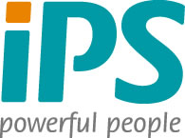
Press Release

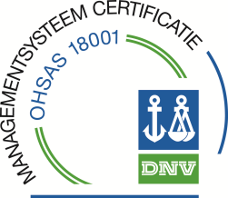
iPS – Powerful People is OHSAS 18001:2007 certified

Crewing and recruitment agency iPS is happy to announce that as per July 18th, the company is OHSAS certified. OHSAS stands for Occupational Health and Safety Assessment Series and is an international standard for safety management.

“This is an important milestone for our company and confirms our outlined values and quality management policy”, says Erwin Broeders, Director of iPS.

The company is already certified according ISO 9001:2008. ISO and OHSAS are the building stones of the continuously improving Company Management System (CMS) of iPS. Safety is a crucial and fundamental element of our way of working.

For our clients and candidates, these certificates are an important safeguard for the quality and safety standards that we apply.

www.ipspowerfulpeople.com

